CHAPTER 8: The dynamic Earth
© MAPgraphics Pty Ltd, Brisbane
Worksheet 8.2

Plate tectonics
Student: Class:

Movement in the South Atlantic
1. The following diagram shows the ocean floor of the South Atlantic Ocean.
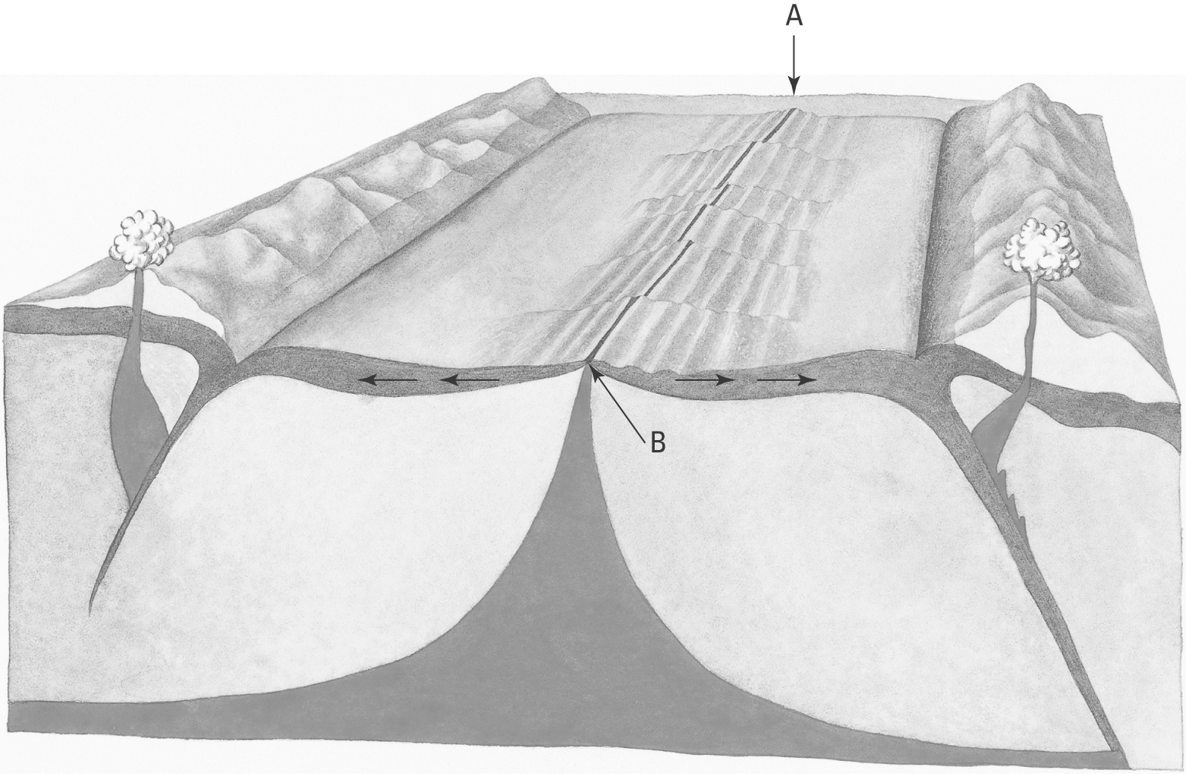
(a) Identify the feature labelled A.
(b) Identify the material rising up to the surface at B.
(c) On the diagram draw in the convection currents in the upper mantle (asthenosphere).
(d) Explain why the South American plate and the African plate are moving apart.

North of Australia
2. The following map shows the Australian–Indian plate, and other plates to the north. The arrows show the direction of plate movement.
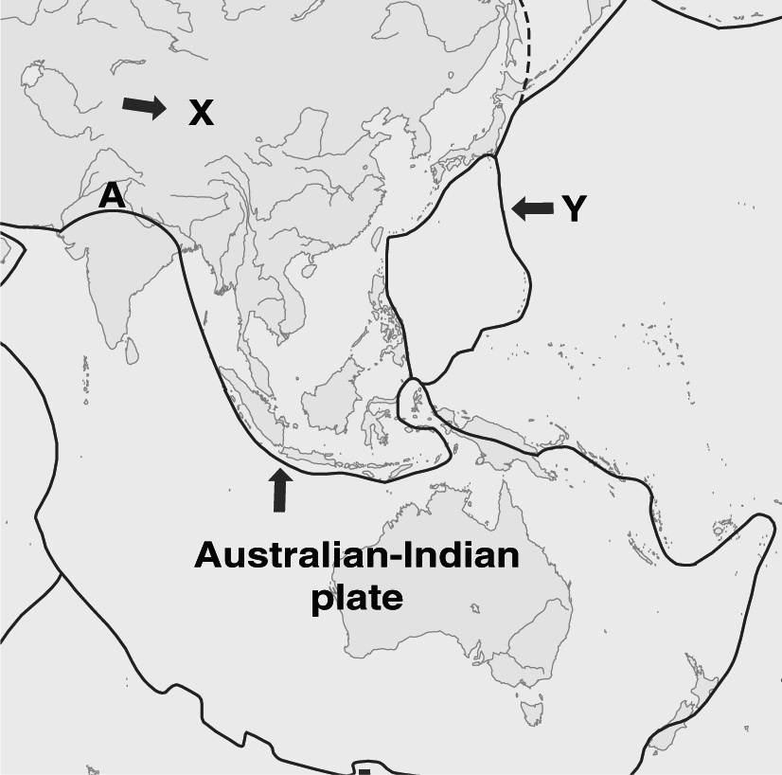 | (a) Name plates X and Y.  X:  Y:  (b) Name the type of plate interaction at location ‘A’.  (c) Name the geological feature resulting from the plate interaction at A.

